Test Case: tc006_SPX_Dev5_Crear_Requisicion_Spot_Tipo_Cobro_Proyect_Urgent
Step 1 - Enter username and password and click to button Enter: Credentials Entered
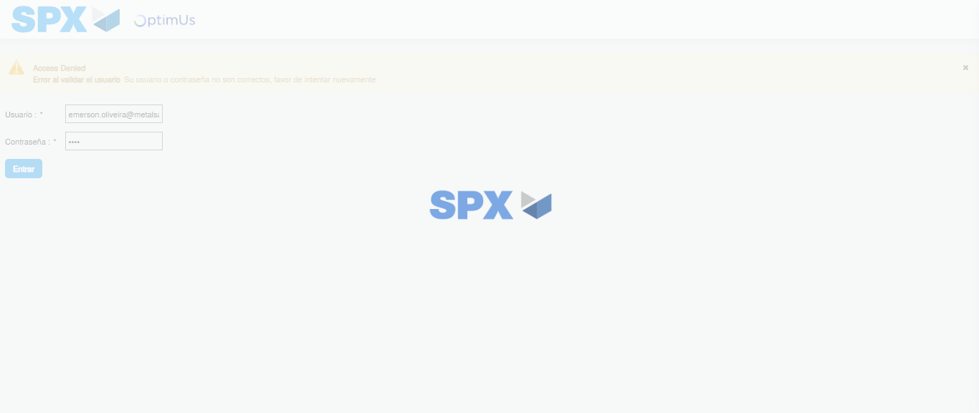Image file-name: QC_Testing-tc006_SPX_Dev5_Crear_Requisicion_Spot_Tipo_Cobro_Proyect_Urgent-1785976028228

Step 2 - Select to UEN and Access to Spot Buy Requisitions : UEN Correctly selected and Correct access
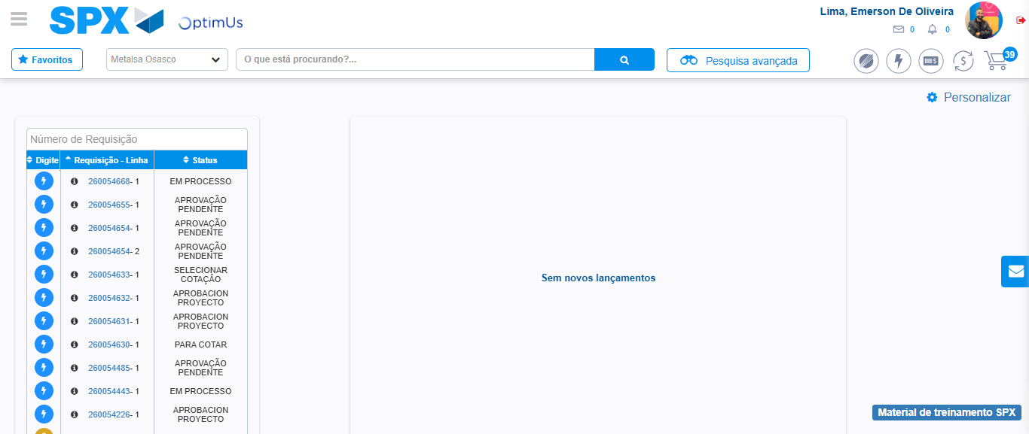Image file-name: QC_Testing-tc006_SPX_Dev5_Crear_Requisicion_Spot_Tipo_Cobro_Proyect_Urgent-1785976052718

Image file-name: QC_Testing-tc006_SPX_Dev5_Crear_Requisicion_Spot_Tipo_Cobro_Proyect_Urgent-1785976055307

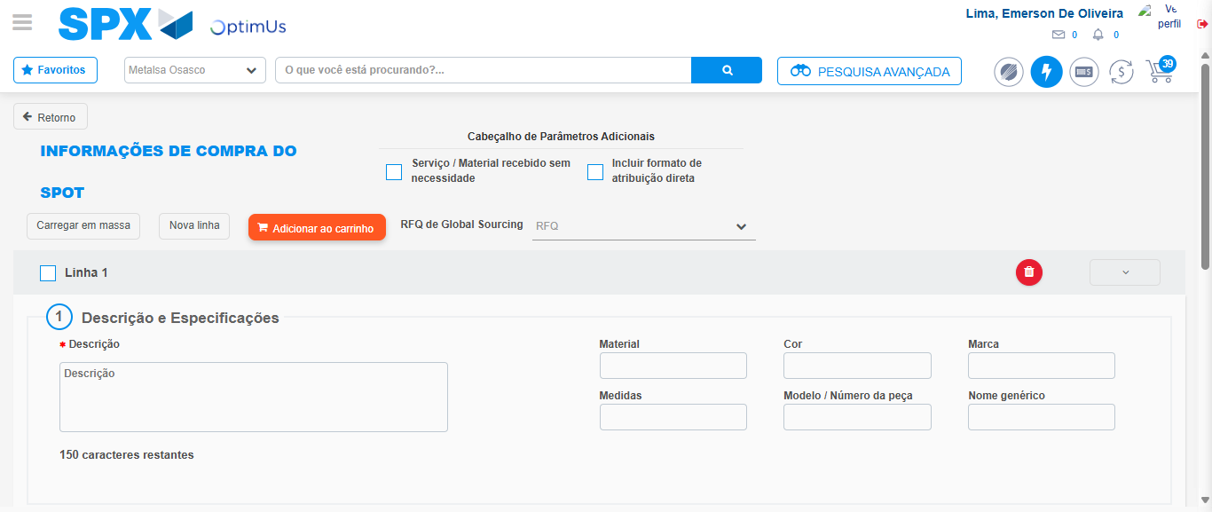Image file-name: QC_Testing-tc006_SPX_Dev5_Crear_Requisicion_Spot_Tipo_Cobro_Proyect_Urgent-1785976064847

Step 3 - Data Capture Spot Buy Requisition: Data captured correctly
Image file-name: QC_Testing-tc006_SPX_Dev5_Crear_Requisicion_Spot_Tipo_Cobro_Proyect_Urgent-1785976065131

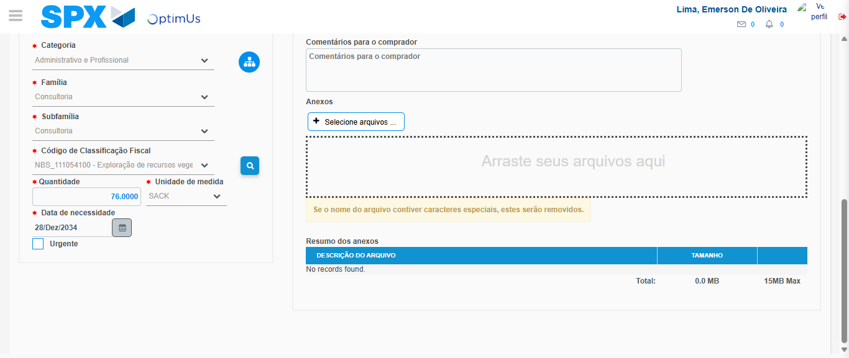Image file-name: QC_Testing-tc006_SPX_Dev5_Crear_Requisicion_Spot_Tipo_Cobro_Proyect_Urgent-1785976080920

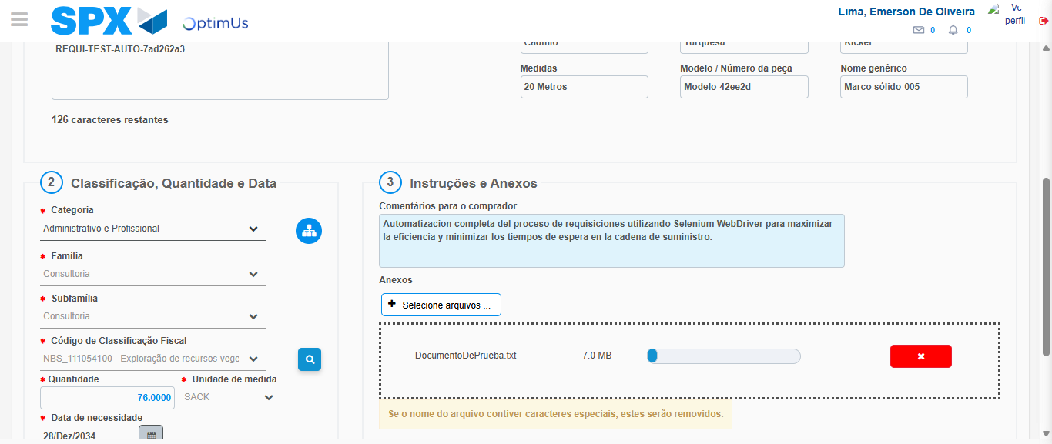Image file-name: QC_Testing-tc006_SPX_Dev5_Crear_Requisicion_Spot_Tipo_Cobro_Proyect_Urgent-1785976081724

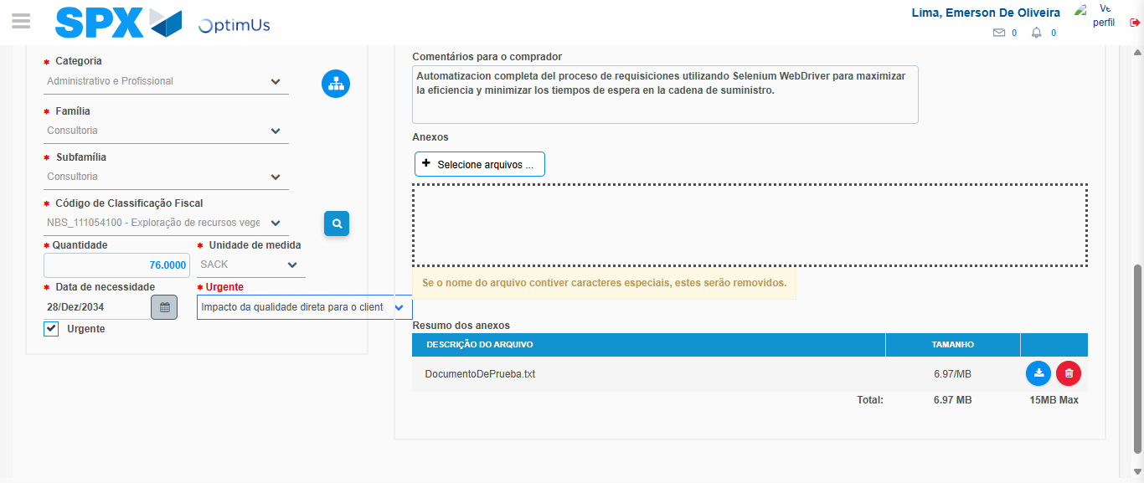Image file-name: QC_Testing-tc006_SPX_Dev5_Crear_Requisicion_Spot_Tipo_Cobro_Proyect_Urgent-1785976085454

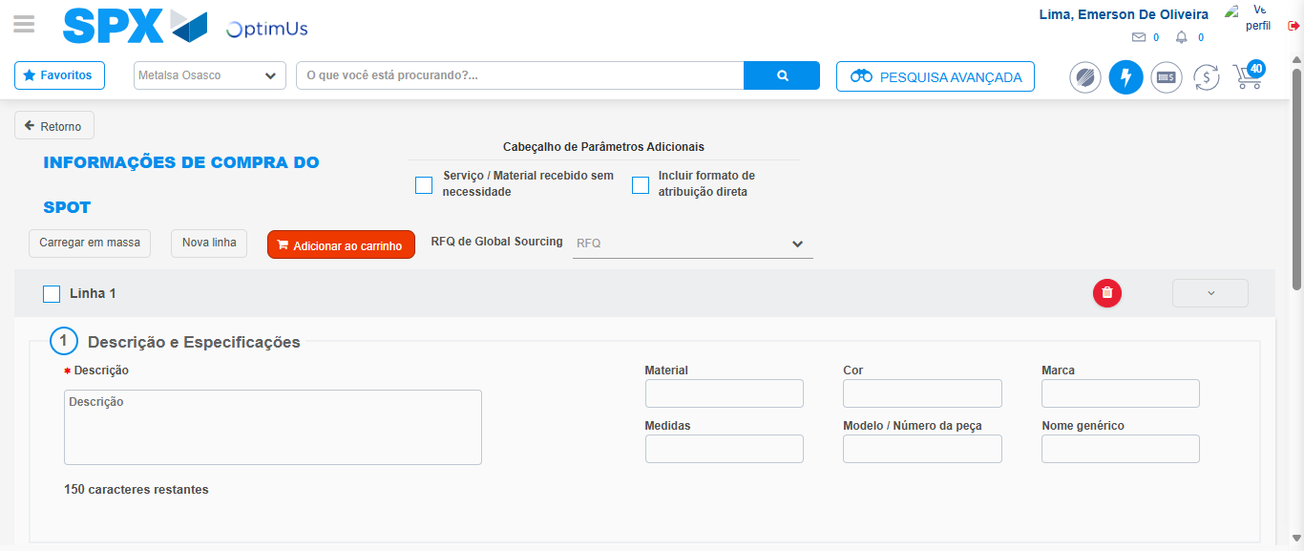Image file-name: QC_Testing-tc006_SPX_Dev5_Crear_Requisicion_Spot_Tipo_Cobro_Proyect_Urgent-1785976092423

Step 7 - Return to Main Page SPX : Return to Main Page SPX
Image file-name: QC_Testing-tc006_SPX_Dev5_Crear_Requisicion_Spot_Tipo_Cobro_Proyect_Urgent-1785976052718

Image file-name: QC_Testing-tc006_SPX_Dev5_Crear_Requisicion_Spot_Tipo_Cobro_Proyect_Urgent-1785976055307

Image file-name: QC_Testing-tc006_SPX_Dev5_Crear_Requisicion_Spot_Tipo_Cobro_Proyect_Urgent-1785976064847

Image file-name: QC_Testing-tc006_SPX_Dev5_Crear_Requisicion_Spot_Tipo_Cobro_Proyect_Urgent-1785976094632

Image file-name: QC_Testing-tc006_SPX_Dev5_Crear_Requisicion_Spot_Tipo_Cobro_Proyect_Urgent-1785976094790

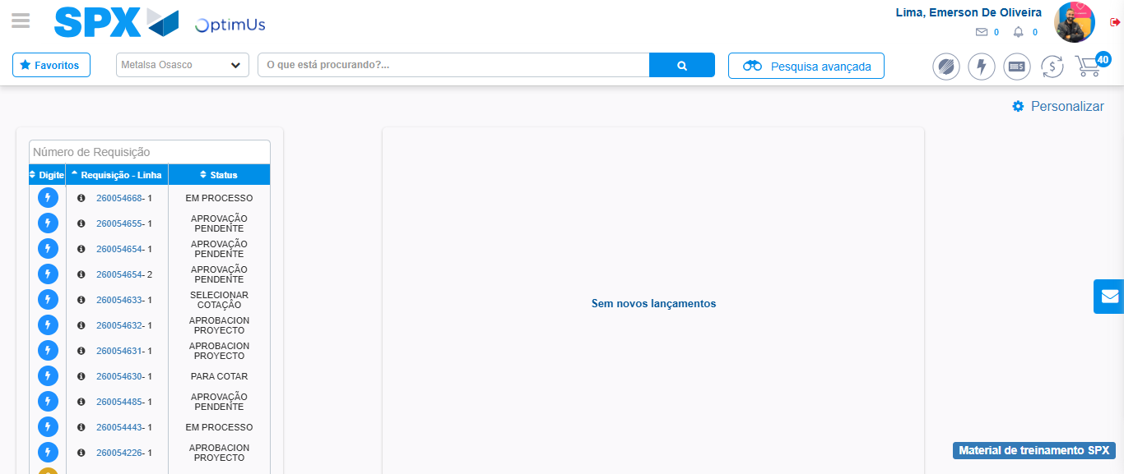Image file-name: QC_Testing-tc006_SPX_Dev5_Crear_Requisicion_Spot_Tipo_Cobro_Proyect_Urgent-1785976115808

Step 8 - Log Out : Log Out SPX
Image file-name: QC_Testing-tc006_SPX_Dev5_Crear_Requisicion_Spot_Tipo_Cobro_Proyect_Urgent-1785976116048

